G4C Future Leader

**GENERATION 4 CHANGE (G4C North West) AWARDS ENTRY FORM**

**Please read and understand the criteria and guidelines before completing this form.**

**Guidelines on ‘How to Enter’ can be found at the end of this document**

**Please remember that:**

1. Information above the specified word limits will not be taken into consideration.
2. Charts and photos should be embedded in the word document where possible (captions are not part of the word count). Total submission length - maximum 15 pages.
3. Appendices will be reviewed as part of the submission.
4. Following the shortlist announcement, we may conduct an interview stage.

**Category Description:**

**G4C is a driving force for industry change, through the development and connection of future industry leaders. The award is open to a person with less than ten years of experience in the construction and built environment sector (typically less than 35 years of age).** **Regional winners of this category will be automatically entered into the National Constructing Excellence Awards where the National G4C Future Leader will be awarded.**

Judges are looking for the person that best demonstrates a positive impact on their peers, their organisation and the wider industry, against current G4C priority areas of people development, sustainability and innovation.

Our winner will have shown potential to become an exemplary future leader, evidenced by a number of the following attributes:

1. Being a leading thinker and champion for change.
2. Ability to positively impact the behaviour of others.
3. A collaborative approach to problem solving and delivery of outcomes.
4. Creativity and ability to think differently, generate ideas and see them through to implementation.
5. Ability to drive positive and sustained change for the benefit of their organisation, community and environment.

|  |
| --- |
| **Entry Checklist:**   1. **Completed entry form** – low resolution images can be embedded to support your entry. 2. **Logos** – for all key parties that should be recognised for the award (original .eps files). 3. **High resolution images** (print quality) – up to 5 photos. 4. **Video answering question 9** – Max 2 minutes long   **Contact:** Sandra Janik (G4C North West Chair) – [sandra.janik@turntown.co.uk](mailto:sandra.janik@turntown.co.uk) |

G4C Future Leader

**GENERATION 4 CHANGE (G4C North West) AWARDS ENTRY FORM SECTION 1 OF 2**

|  |  |  |
| --- | --- | --- |
| **Is your entry?** | a personal entry | a nomination |

**Main contact** (this relates to questions/queries about the entry)**:**

|  |  |
| --- | --- |
| Name |  |
| Organisation |  |
| Email |  |
| Telephone |  |
| Address |  |
| Postcode |  |

**Nominee’s contact details:**

|  |  |
| --- | --- |
| Name |  |
| Position |  |
| Current employer |  |
| Type of organisation | (i.e. housing association, developer, government department, contractor, consultant etc) |
| Linkedin Profile |  |

IMPORTANT: Headshot/images – please supply HIGH QUALITY **.eps** or **.jpeg** logo files for all organisations mentioned.

These logos will be etched onto the glass trophies presented to winners.

G4C Future Leader

**GENERATION 4 CHANGE (G4C North West) AWARDS ENTRY FORM SECTION 2 OF 2**

|  |
| --- |
| 1. **Summary** (**max. 500 words**)   * Please provide a clear summary of all key messages and aspects of the submission. This section will be used for marketing purposes. A clear and full answer ensures we showcase your project effectively. *  **Guidance questions:** What makes this person a winning individual? Why do you think this individual stands out from the crowd? How do you suggest we share what they do with the industry? |
|  |

|  |
| --- |
| 1. **Overview:** Describe the individual’s role and the context of the submission.(**max. 250 words**) |
|  |

|  |
| --- |
| 1. **Leadership & influence:**   How has the individual’s performance as a leading thinker and champion of change influenced their own and performance of others? This could also include evidence of leadership attributes.(**max. 250 words**) |
|  |

|  |
| --- |
| 1. **Collaboration:**   Evidence of the individual’s collaborative approach to problem solving and the delivery of outcomes, including the approach to building trusting, open relationships with team members and stakeholders across organisational boundaries.  (**max. 250 words**) |
|  |

|  |
| --- |
| 1. **Innovation:**   Evidence of individual’s creativity and ability to think differently, generate ideas, gain buy-in and see them through to implementation, including the benefits achieved as a result.(**max. 250 words**) |
|  |

|  |
| --- |
| 1. **Sustainability:**   Evidence of individual’s awareness of sustainability, be it economic, social and/or environmental, and ability to passionately drive positive change and tangible outcomes for their organisation, community and environment.  (**max. 250 words**) |
|  |

|  |
| --- |
| 1. **Legacy:**   Evidence of individual’s record in delivering sustained change, including the on-going benefits of the change achieved as a legacy to the industry. **(max. 250 words**) |
|  |

|  |
| --- |
| 1. **Describe how the individual has demonstrated a positive impact by acting as an intelligent client to their supply chain.**   **(max. 250 words**) |
|  |

|  |  |
| --- | --- |
| 1. **3 reasons why this individual should win. Please submit the answers to this question in video format of the individual.**   Ensure you highlight 3 **key** achievements. | |
| **1** |  |
| **2** |  |
| **3** |  |

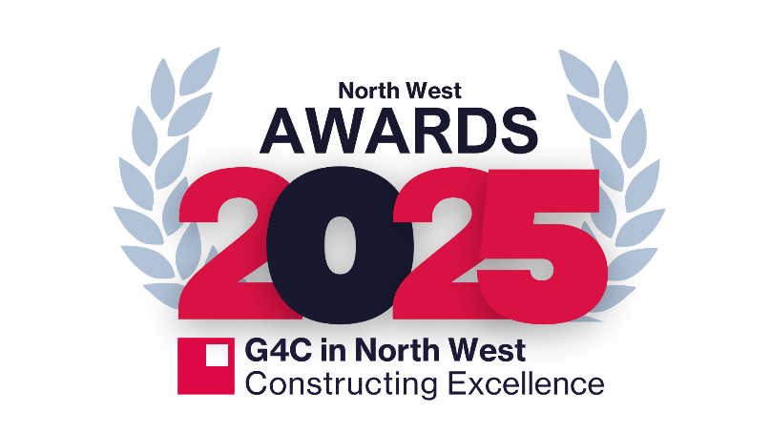

**GENERATION 4 CHANGE NORTH WEST AWARDS**

**Important information on how to enter:**

**Qualifying**

* All categories have separate application forms relating to the criteria of the specific award.
* Where an individual or organisation is entering the nominating organisation/divisional office/individual should be based in the North West

**How to enter - Entry Guidelines**

* All submissions must be made by **17.00 on 25th April 2025**
* **Please submit your applications to Sandra Janik -** [**sandra.janik@turntown.co.uk**](mailto:sandra.janik@turntown.co.uk)
* Please include with your submissions the company logos (JPEG/EPS format) where applicable.
* Please include a selection of photos that we may use should you be shortlisted (MUST be high resolution no PDF’s or Word documents)
* The organisers have the right to reject any entry if, in their opinion, it fails to comply with the rules

**Judging**

* The panel of judges will consider each submission against the category criteria.
* Winners will be announced at a venue in the North West (Venue TBC) in June 2024.
* A minimum of 1 ticket must be purchased for the awards dinner.
* All awards are made at the discretion of the judges and Constructing Excellence in the North West.
* The right is reserved not to make awards in a particular category.
* The judges reserve the right to refuse entries without giving reasons.
* The judges have authority to move entries into more applicable categories. Their decision is final and no correspondence will be entered into following the Awards.
* Information supplied by the judges, or discussed between the judges and entrants will be treated in complete confidence, and confidentiality on the part of the entrants if requested.

**Good Luck!**

**If you have any questions relating to your entry, please contact Sandra Janik -** [**sandra.janik@turntown.co.uk**](mailto:sandra.janik@turntown.co.uk)