Construction (Design and Management) Regulations 2015: Update 27Feb2015
The new Regulations (CDM 2015) will come into force on 6th April 2015.

Summary  - CDM Regs revisions, coming into force on 6 April 2015, will be the largest change to construction legislation since 2007  - The CDM Regulatory package will consist of:  - The CDM Regulations  - HSE ‘L’ series (legal) guidance  - CONIAC Industry guidance  - All projects, including domestic client work, will need to produce a construction phase plan, which means micro, small and SME companies will be affected for the first time  - CITB has been working with HSE and our industry partners to raise awareness and encourage early compliance.  Final Industry Guidance Documents  Final documents will be available from 6 April to coincide with HSE’s publication of the final Regulations and supporting ‘L’ series guidance.  CITB support activity so far:  - Free CDM Wizard App (Android)  - New web pages hosting the draft industry guidance documents  - NCC subsidised £25 ½ day workshop  - CDM compliant products and publications  - Builders’ Merchants engagement.  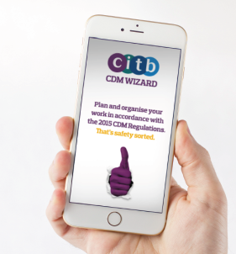  Some early engagement indicators:  - 42,178 – visits to citb.co.uk/cdmregs  - 42,250 – guidance documents downloaded  - 1,757 – workshops booked  - 300+ – apps downloaded.  CDM Wizard app – although our free app is targeted primarily at micros and small companies, we are hearing that larger organisations are also using it, and it is also being used for training purposes. It’s also featured in HSE’s Construction Inspectors briefings and mentioned in the HSE ‘L’ Series guidance. | CITB activity underway:  Marketing campaign  Aimed primarily at hard-to-reach micro companies, our high impact ‘Safety Sorted’ campaign will start from 2 March:  - digital activity, on mobiles and around social media sites  - key trade press advertisements  - TalkSport radio pilot  - direct mail and email  - industry partner material ‘toolkit’  - digital content marketing plan including animations and videos.  Also:  - CDM Wizard App iOS version (Apple)  - Advisory Forums employer briefings  - Qualitative research in March and October.  How you can help us achieve early compliance  Please advise your members:  - to download the final industry guidance documents on 6 April, even if they have already downloaded the draft documents (there have been changes)  - to go to citb.co.uk/cdmregs for the latest information, to book a course or download the App.  Help us spread the word by  - Putting our promotional box on your website to take people to citb.co.uk/cdmregs  - Handing out business cards with the web address on them at your local, regional and national events.  Further information from: Fiona Wilson, Marketing Manager, CITB. Fiona.wilson@citb.co.uk.

